YOU SHOOT, YOU SCORE! MAYBE?

article “6 Goal Setting Factors You Need to Understand” and you should have a good idea of what goal setting methods you might be able to implement.
Now, the question is, what are some of your goals?

Within the next year, what are your goals around:
- where you will live (country, community, dwelling,...)
- places you will visit (countries, areas, institutions - like museums, landmarks,...)
- clothes you will wear
- vehicle(s) you will drive
- what you will be doing with your life (going to post-secondary, backpacking through Australia, working ,...)
- who your family will consist of (parents and siblings, grandparents and cousins, significant other and child,. . .)
- other goal(s) you think you will be working towards achieving.

Within five years, what are your goals around:
- where you will live (country, community, dwelling,...)
- places you will visit (countries, areas, institutions - like museums, landmarks,...)
- clothes you will wear
- vehicle(s) you will drive
- what you will be doing with your life (going to post-secondary, backpacking through Australia, working ,...)
- who your family will consist of (parents and siblings, grandparents and cousins, significant other and child,. . .)
- other goal(s) you think you will be working towards achieving.

Within ten years, what are your goals around:
- where you will live (country, community, dwelling,...)
- places you will visit (countries, areas, institutions - like museums, landmarks,...)
- clothes you will wear
- vehicle(s) you will drive
- what you will be doing with your life (going to post-secondary, backpacking through Australia, working ,...)
- who your family will consist of (parents and siblings, grandparents and cousins, significant other and child,. . .)
- other goal(s) you think you will be working towards achieving.

- Your job:

Create a collage (or three) depicting your goals for these three time periods. You are welcome to complete it in the software of your choosing or to complete it by hand. Thinking about this assignment, I would probably do it in PowerPoint or GoogleSlides so I could have a slide per time period BUT you are welcome to make it however you see fit. (3 time periods x 10 marks/time period = 30 marks)
Think about how you will accomplish these goals? What will you need to acquire, earn and maintain these goals? What steps will need to be incorporated?
Select two of your goals from each of the time frames. Explain (again in a software of your choosing) how you plan on accomplishing those goals. Use one of the goal setting methods outlined previously OR use a method you are already familiar with, but detail your process. (3 time periods x 2 goals/time period x 8 marks each = 48 marks).

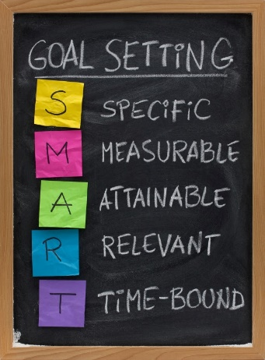
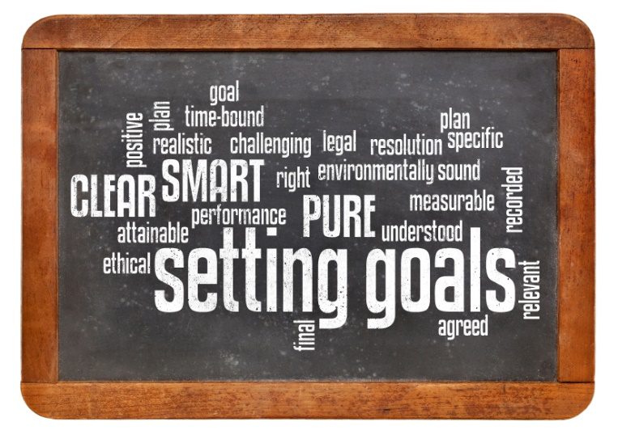
Submit all of your relevant files (or links) by by emailing them to me at margot.arnold@secpsd.ca.

